**Light field**

Suppose there is a point source that emits light everywhere and we have an array of cameras taking photos of this point source, we can get 4D radiance information as a function of x, y, and two angles of light rays starting from the point source. This 4D radiance function is called light field. Another way of describing light field is to record the two intersection points between a certain light ray and two planes in propagation space. Specifically, light field, in this case, is a radiance function with respect to (u, v, s, t), and (u, v) denotes the intersection location at the first plane, and (s, t) denotes that at the second plane. Both methods correspond to their practical recording devices: the former, obviously, is a camera array and the latter is a modified camera with a microlens array at the previous sensor plane and a displaced sensor behind.

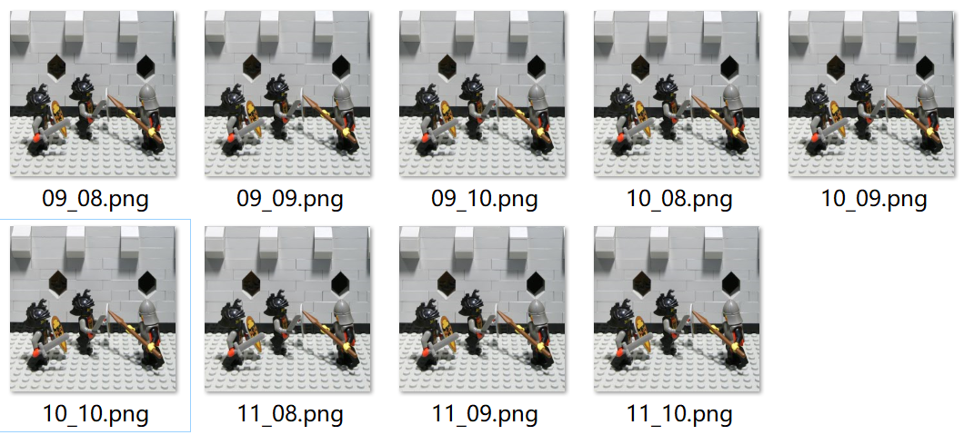

Fig1. Light field captured through a camera array.

Two types of light field data can be transformed. Fig2 shows the light field captured by a camera with a microlens array and it is composed of a series of subimages, each of which corresponds to one microlens in front. If you choose the pixel at the same position in each sub-image to form an image, you get the one perspective view, like the image from one camera of the camera array in method one. Therefore the pixel number behind each microlens reflects how much angle information is recorded and how many perspective views there are. If you sum the images of all the perspective views, you will get an image as one from a conventional camera, but with a lower resolution.



Fig2. Light field captured by a camera with a microlens array.

Once the 4D light field is obtained, the new synthetic light field expressed by the new synthetic aperture (one plane) and film (another plane) can be deduced. Furthermore, the angle and location information describing how light rays travel or propagate through a designated plane can be calculated and the irradiance image there can be simulated or synthesized. Light field photography applies such principles to implement image rendering and postprocessing, specifically including digital focusing, depth of field extension, and perspective switch (digitally moving the observer). Without any doubt, the most well-known is digital refocusing which is achieved by summing shifted images of different perspective views. The paper (Ren Ng, 2005) gives the details of the shift.

A microscope is orthographic because of the telecentric stop inside. Unlike perspective devices, orthographic devices have no parallax, which means the image looks the same when moving the object laterally, crucial for accurate measurement. Combining light field technology with microscopy reaches light field microscopy which enables prospective function (allowing observation of samples from different perspective views) and further function of 3D imaging.

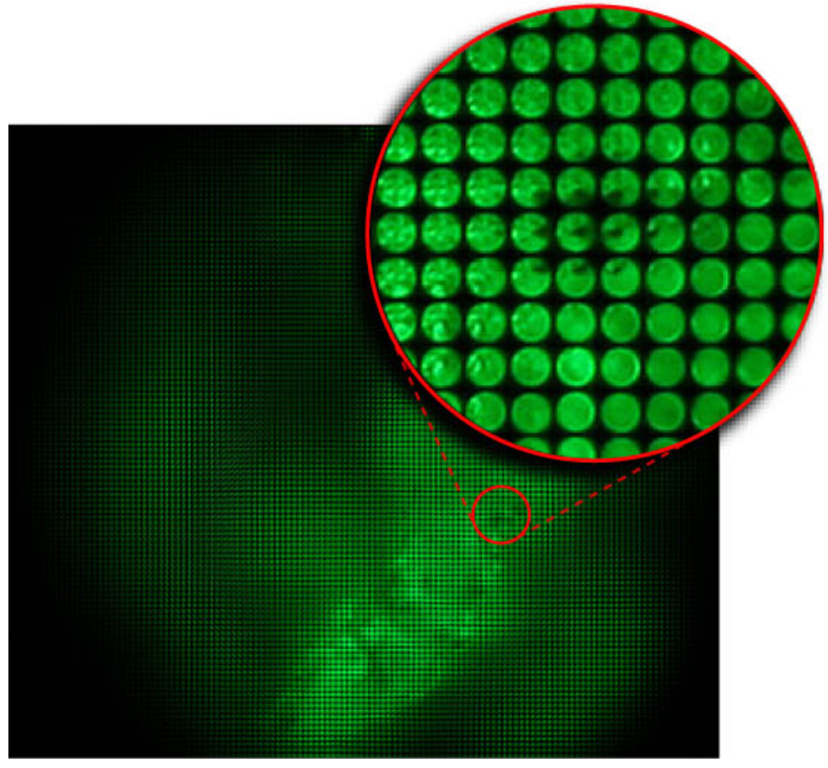

Fig3. An image from light field microscopy.